**About Storage**

Click volume and show the volumes

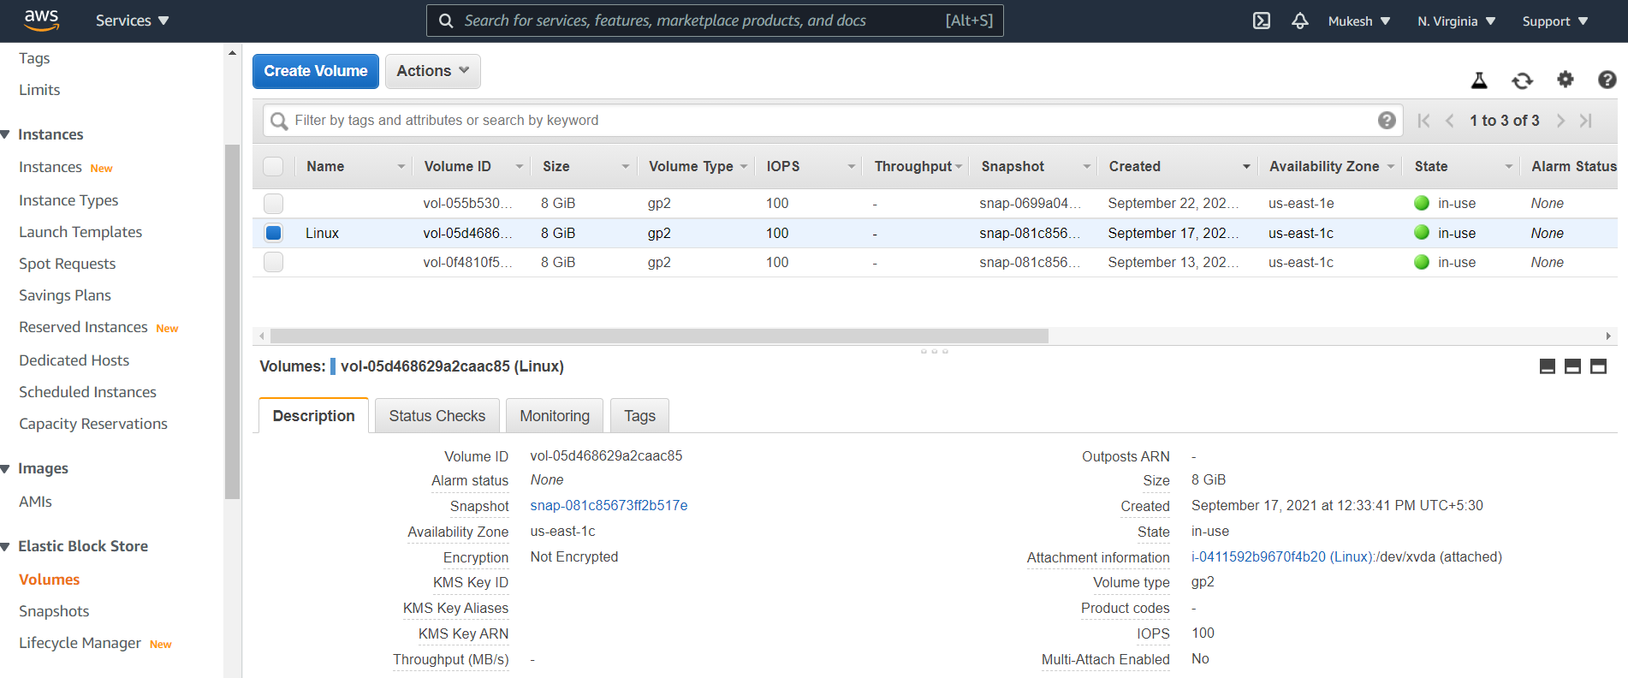

Then, click already created volumes like name of volume (Linux)

And click Action🡪view the some configuration settings

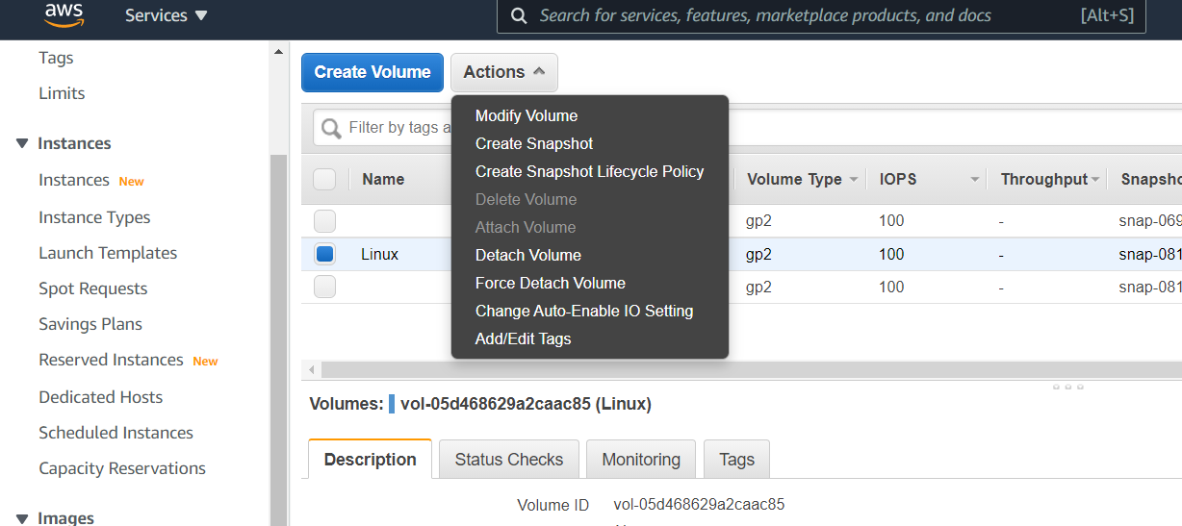

Click modify🡪show the below statement.it means we can only increase the volume size not decreased.

